CAMPING CHECKLIST
Shelter  - Tent  - Ground cloth  - Spare tent stakes  - Tent light |  |  | Sleeping Comforts  - Sleeping bag  - Pillows  - Pads or air mattress  - Alarm clock |  |  |  | Lights  - Lantern  - Flashlights  - Headlamps  - Tent lamp  - Spare batteries
Fire  - Firewood  - Kindling and tinder for starting the fire  - Matches – keep in a waterproof container  - Fire extinguisher  - Shovel |  |  | Tools  - Sharp Pocket knife  - Pliers  - Screw driver  - Or, a good multi-tool that includes the above functions  - Hammer  - Small shovel  - Axe |  | 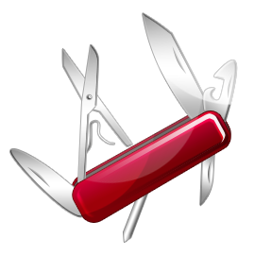 |  | Camping Toolbox  - Duct tape  - Work gloves  - Bunge cords  - Trash bags  - Rope  - Small broom and dustpan  - Extra batteries  - First aid kit  - Insect repellant
Safety  - Whistle  - Compass  - Cell phone (verify if campsite is within cell phone range)  - Walkie talkie – great for kids or if campsite is outside of cell phone range |  |  | Campsite Comfort  - Chairs  - Stools  - Games and pass time activities  - Blankets and pillows |  |  |  | Cooking Gear  - Camp stove and fuel  - Grill, lighter fluid, charcoal  - Cooking pots and pans  - Cooking utensils – serving spoons, spatula, knives, etc.  - Can opener  - Camping coffee pot  - Dining ware for each camper– plates, cups, bowls, knive/fork/spoon
Kitchen Supplies  - Paper towels  - Basin for washing dishes and cookware – large plastic pan works well  - Dishwashing detergent  - Dishrag, sponge, scrubber  - Dish towels  - Trash bags  - Foil – go with the heavy duty  - Plastic wrap  - Zip lock bags |  |  | Food  - Groceries for all meals planned  - Bread  - Sandwich meat and cheese  - Peanut butter and jelly  - Fresh fruits and vegetables  - Beverages – hot and cold  - Condiments—salt, pepper, sugar, mustard, ketchup  - Campfire snacks – the makings for smores, popcorn  - Sticks or wire coat hangers for roasting the marshmallows  - Water – a gallon for each camper per day unless you know for sure drinking water is available at the campsite |  |  |  | Toiletries  - Toothbrush/toothpaste  - Bath towels/washcloths  - Soap – in plastic container  - Deodorant  - Shampoo & conditioner  - Comb and brush  - Razor/shaving cream  - Female hygiene products  - Sunscreen  - Lotions and lip balm  - Mirror  - Medications – aspirin, ibuprofen, anti-itch  - Prescriptions
Have a wonderful time on your camping trip!
www.TheBestCampingTips.com

